**How do I enable the Internet on VirtualBox?**

When we create a new Virtual machine in VirtualBox and install any Operating system in that machine, it is often faced that the internet is not working or not connected. There can be multiple reasons if the internet is not working on the Virtual machine in the VirtualBox. This post will help you and provide you a step-by-step guide on fixing or enabling the internet connection in a virtual machine of VirtualBox.

**Step 1: Ensure the internet connection**First, ensure that the wired network connection is already turned on by going to the network tab in the settings.

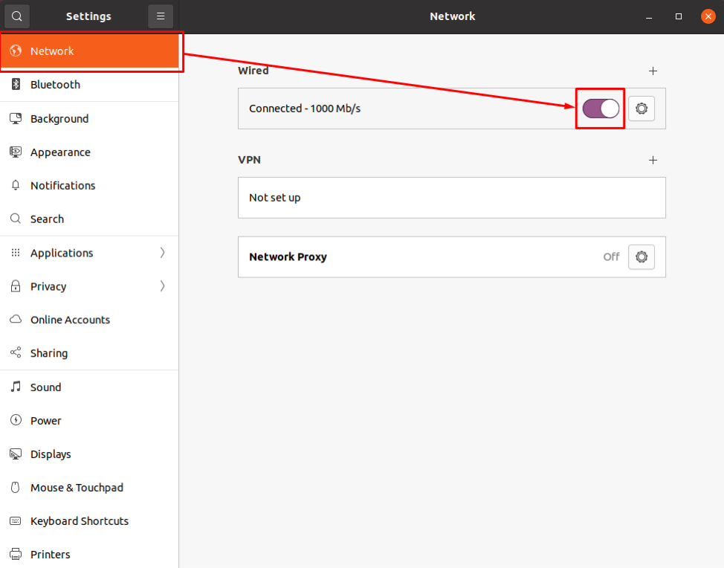

1 second of 15 secondsVolume 0%

If the highlighted toggle button in the screenshot attached is OFF, then turn it ON and establish the internet connection.

**Step 2: Turn OFF the Virtual Machine**If you still do not have the internet connection established, you need to change the machine’s network adapter settings from the Virtual machine settings.

For changing the network settings and for the modifications to take effect, turn off the virtual machine.

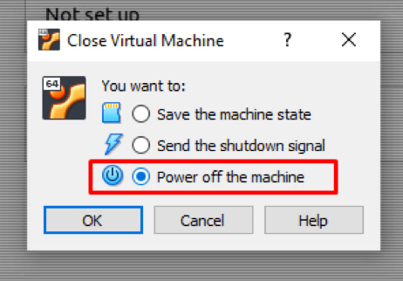

**Step 3: Open network settings of Virtual Machine**After closing the Virtual Machine, open the virtual machine settings by right-clicking on the machine and selecting the settings option from the context menu.

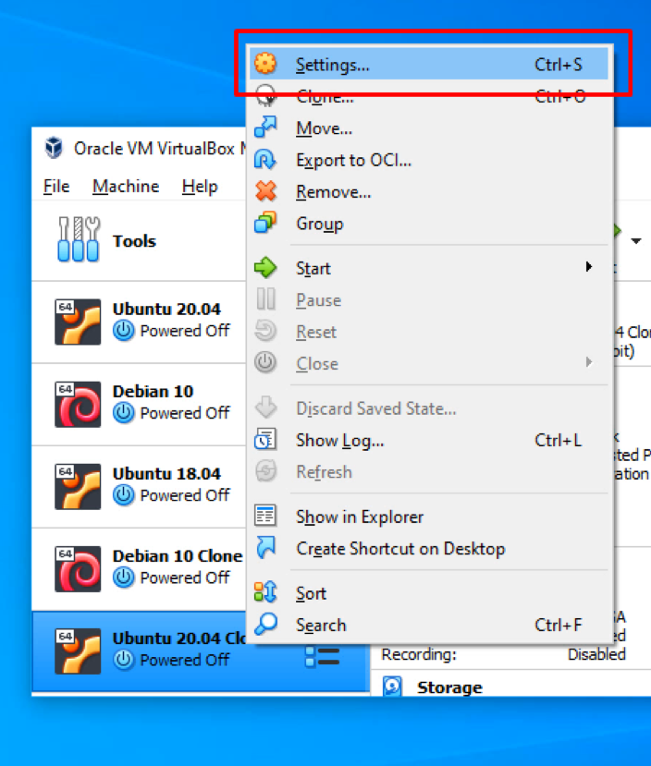

In the settings window that appeared, click on the Network tab from the left bar.

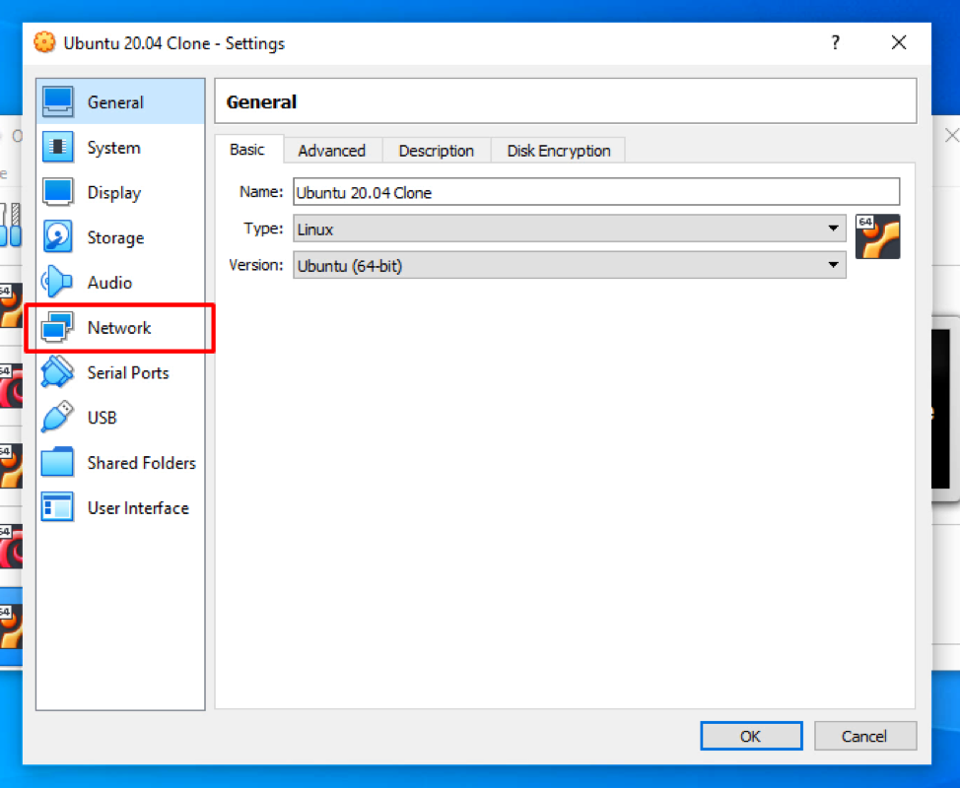

**Step 4: Enable the Network Adapter**In the machine’s Network Adapter settings, click on the “Enable Network Adapter” to enable the network adapter and modify its settings.

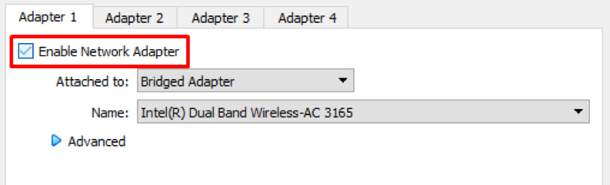

If it is unchecked, then definitely this was the reason behind the internet connection not working because there was no network adapter assigned to the Virtual machine by the VirtualBox.

**Step 5: Select the Network Device**After enabling the network adapter for the virtual machine, you can select the preferred method from the “attached to” dropdown menu to attach the virtual network adapter to your host OS network.

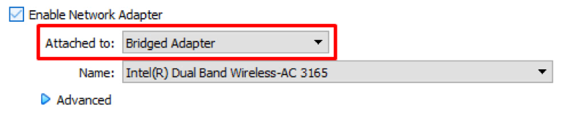

We will suggest selecting the **Bridged Adapter** because this way, the virtual machine will be connected to the network using the host OS Ethernet adapter.

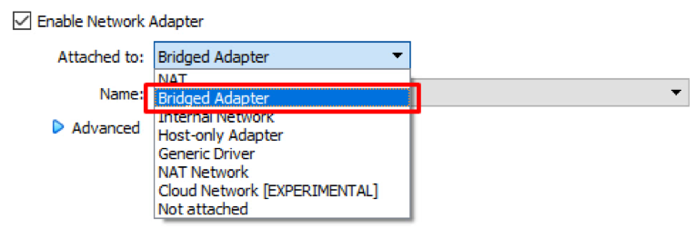

After selecting the appropriate method from the “Name” drop-down, select the right device that you want to choose.

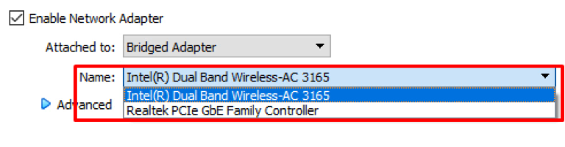

**Step 6: Save Settings and start the Virtual Machine**After configuring all the described settings, click on the OK button to save the settings.

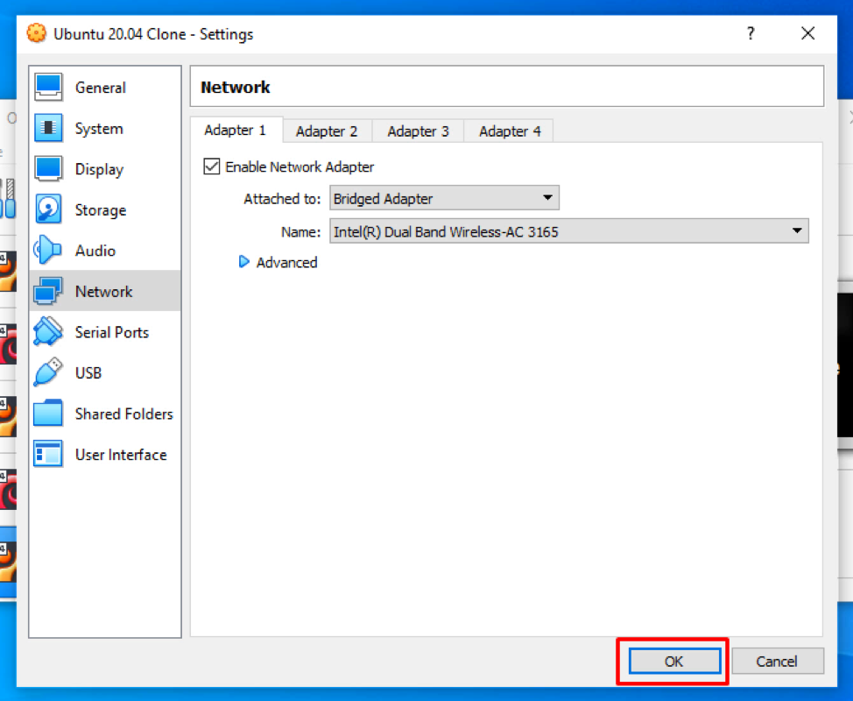

And start the machine by double-clicking on the machine.

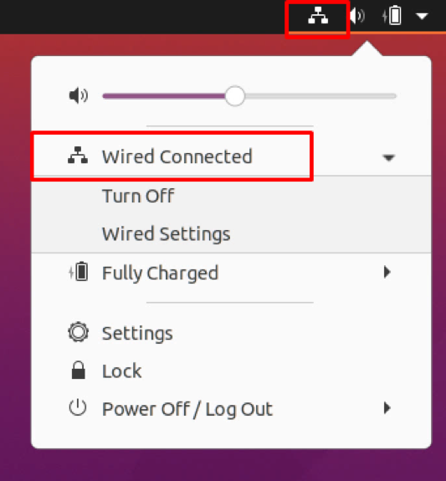

You will have the internet connection working perfectly fine on your virtual machine in the virtual box.